**DEPARTMENT OF COMPUTER APPLICATIONS**

**National Institute of Technology Kurukshetra Haryana, India**



**OOPs Project (MCA-104)**

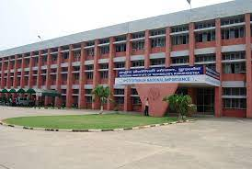

**Submitted To:-**

**Dr. Kapil Gupta**

**DOUBT RESOLUTION**

A project report submitted in partial fulfilment of the requirement for the award of the degree of

## “Master of Computer Applications”

***Submitted By***

|  |  |
| --- | --- |
| 1. Shubham Kumar Shaw | 523110001 |
| 2. Armaan Vasal | 523110039 |
| 3. Saksham Singh | 523110010 |
| 4. Shivam Prajapati | 523110023 |

## UNDER THE SUPERVISION OF

**Dr. Kapil Gupta**

(Internal Supervisor)

Department of Computer Application

NIT KKR



This project is a result of dedicated effort. It gives us immense pleasure to prepare the project on **“Doubt Resolution”**.

We would like to extend our gratitude to our **project incharge Dr. Kapil Gupta** for consultative help and constructive suggestions on matter of this project. We would also like to thank all those who have indirectly helped us in making this project a successful one**.**

**CONTENTS**

Introduction 4-5

Analysis and Design 6

Source Code 7-89

Screenshots 90-92

Conclusion 93

Reference 94

Biblography 95

|  |  |
| --- | --- |
|  |  |
| **‘’Doubt Resolution”**  In an ever-evolving landscape of information and technology, the pursuit of knowledge often gives rise to doubts and questions. The Doubt Resolution Project emerges as a beacon of clarity in the vast sea of uncertainties, dedicated to providing effective solutions and answers to the queries that perplex minds.  The Doubt Resolution Project envisions a future where the pursuit of knowledge is not hindered by uncertainties but rather fueled by a supportive community and accessible resources. Through a commitment to excellence, collaboration, and innovation, the project aspires to become a go-to destination for individuals seeking resolution to their doubts, ultimately contributing to a more informed and enlightened society.  **i.) Purpose :-**  The Doubt Resolution Project serves several crucial purposes, aiming to address the challenges individuals face when seeking answers and understanding across diverse domains.  the purpose of the Doubt Resolution Project is to facilitate learning, empower individuals, foster collaboration, and build a robust knowledge-sharing ecosystem where doubts are not barriers but stepping stones toward greater understanding and personal development.  **ii.) Scope :-**  The scope of a Doubt Resolution Project is broad, encompassing various domains and catering to the diverse needs of individuals seeking clarification and understanding. The project's scope extends across different dimensions to ensure its effectiveness and relevance. |  |
| In essence, the scope of a Doubt Resolution Project is expansive, encompassing diverse subjects, academic levels, and professional domains. By combining community engagement, technological innovation, and subject expertise, the project endeavors to create a holistic and inclusive platform for individuals seeking answers and clarity in their intellectual pursuits.  **iii) Objective :-**  The primary objective of the Doubt Resolution Project is to create a dynamic and accessible platform where individuals can seek resolution for their doubts across various domains, including academics, technology, science, and more. By fostering a community-driven approach, this initiative aims to bridge the gap between inquiry and understanding, promoting knowledge exchange and collaboration. |  |
|  |  |

**Analysis and Design**

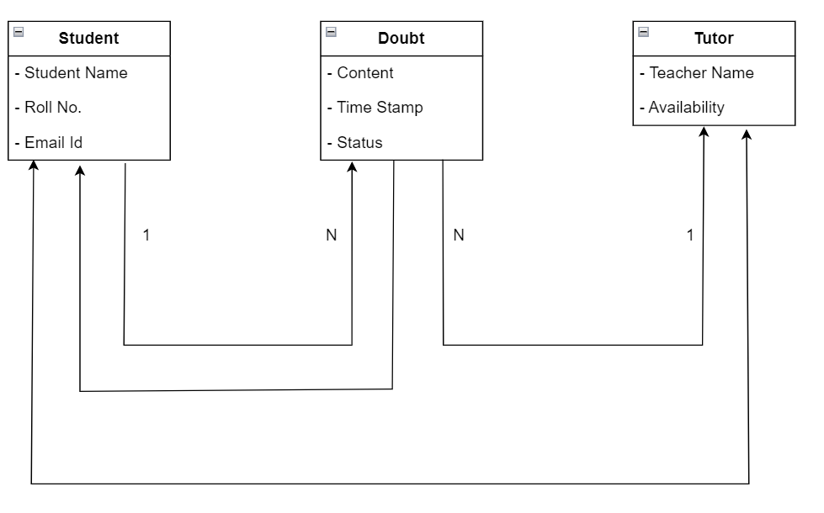

**SOURCE CODE**

* **DoubtResolution.java**

import java.util.*; //Scanner Class

public class DoubtResolution // class name

{

static void display() {

for (int i = 1; i <= 153; i++) {

System.out.print("-");

}

System.out.println();

}

public static void main(String[] args) // main method

{

Scanner sc = new Scanner(System.in); // Scanner class

System.out.println(

"............................................................WELCOME TO DOUBT RESOLUTION SESSION..........................................................");

display();

System.out.print("ENTER YOUR NAME:");

String name = sc.nextLine(); // Inputing Name

System.out.print("ENTER YOUR ROLLNO:");

int RollNo = sc.nextInt(); // Inputing Roll No

System.out.println("ENTER YOUR EMAIL ID:");

String email = sc.next(); // Inputing Email

Details obj = new Details(name, RollNo, email); // Creating Object

display();

System.out.println("CHOOSE YOUR SEMESTER:");

System.out.println(

"-----------------------------------------------------------------------SEMESTER 1------------------------------------------------------------------------");

System.out.println(

"-----------------------------------------------------------------------SEMESTER 2------------------------------------------------------------------------");

System.out.println(

"-----------------------------------------------------------------------SEMESTER 3------------------------------------------------------------------------");

System.out.println(

"-----------------------------------------------------------------------SEMESTER 4------------------------------------------------------------------------");

System.out.println(

"-----------------------------------------------------------------------SEMESTER 5------------------------------------------------------------------------");

System.out.println(

"-----------------------------------------------------------------------SEMESTER 6------------------------------------------------------------------------");

int ch = sc.nextInt(); // Inputing choice for Semester

System.out.println();

if (ch == 1) {

System.out.println("\tSUBJECT\t\t\t\t\t\t\t" + " DAY\t\t\t\t\t\t\t\t" + " TIMINGS");

System.out.println("1.)Computer Programming Using C\t\t\t\t\t" + "MONDAY\t\t\t\t\t\t\t" + "4:30-5:30 p.m.");

System.out.println(

"2.)Computer Organisation And Architecture\t\t\t" + "TUESDAY\t\t\t\t\t\t\t" + "4:30-5:30 p.m.");

System.out

.println("3.)Discrete Mathematical Structure\t\t\t\t" + "WEDNESDAY\t\t\t\t\t\t" + "4:30-5:30 p.m.");

System.out.println("4.)Microprocessors\t\t\t\t\t\t" + "THURSDAY\t\t\t\t\t\t" + "4:30-5:30 p.m.");

System.out.println("5.)Fundamentals of Management\t\t\t\t\t" + "FRIDAY\t\t\t\t\t\t\t\t" + "4:30-5:30 p.m.");

System.out.println();

System.out.println("CHOOSE YOUR SUBJECT:");

int sub = sc.nextInt(); // Inputing Subject

System.out.println();

Subject2 ob = new Subject2(); // Creating Object for Subjects in Semester 1

switch (sub) {

case 1:

String topic_name = ob.Computer_Programming_Using_C_101(); // Calling Function

System.out.println();

System.out.println("***************BOOKED SUCCESSFULLY!!***************");

System.out.println("---------------------------------------------------");

System.out.println("DETAILS ARE GIVEN BELOW:");

System.out.println("---------------------------------------------------");

System.out.println(

"NAME:-" + obj.name + "\n" + "ROLL NO.:-" + obj.RollNo + "\n" + "SEMESTER:-" + 1 + "\n" +

"SUBJECT:-Computer_Programming_Using_C_101" + "\n" +

"TOPIC NAME:-" + topic_name + "\n" + "WEEK DAY:-Monday" + "\n" +

"TIMINGS:-4:30-5:30 p.m." + "\n" + "FACULTY:-Dr.Sandeep Kumar Sood");

break;

case 2:

String topic_name1 = ob.Computer_Organisation_And_Architecture_103(); // Calling Function

System.out.println();

System.out.println("***************BOOKED SUCCESSFULLY!!***************");

System.out.println("---------------------------------------------------");

System.out.println("DETAILS ARE GIVEN BELOW:");

System.out.println("---------------------------------------------------");

System.out.println(

"NAME:-" + obj.name + "\n" + "ROLL NO.:-" + obj.RollNo + "\n" + "SEMESTER:-" + 1 + "\n" +

"SUBJECT:-Computer_Organisation_And_Architecture_103" + "\n" +

"TOPIC NAME:-" + topic_name1 + "\n" + "WEEK DAY:-Tuesday" + "\n" +

"TIMINGS:-4:30-5:30 p.m." + "\n" + "FACULTY:-Dr.Sarika Jain");

break;

case 3:

String topic_name2 = ob.Discrete_Mathematical_Structure_105(); // Calling Function

System.out.println();

System.out.println("***************BOOKED SUCCESSFULLY!!***************");

System.out.println("---------------------------------------------------");

System.out.println("DETAILS ARE GIVEN BELOW:");

System.out.println("---------------------------------------------------");

System.out.println(

"NAME:-" + obj.name + "\n" + "ROLL NO.:-" + obj.RollNo + "\n" + "SEMESTER:-" + 1 + "\n" +

"SUBJECT:-Discrete_Mathematical_Structure_105" + "\n" +

"TOPIC NAME:-" + topic_name2 + "\n" + "WEEK DAY:-Wednesday" + "\n" +

"TIMINGS:-4:30-5:30 p.m." + "\n" + "FACULTY:-Dr.Sarika Jain");

break;

case 4:

String topic_name3 = ob.Microprocessor_107(); // Calling Function

System.out.println();

System.out.println("***************BOOKED SUCCESSFULLY!!***************");

System.out.println("---------------------------------------------------");

System.out.println("DETAILS ARE GIVEN BELOW:");

System.out.println("---------------------------------------------------");

System.out.println(

"NAME:-" + obj.name + "\n" + "ROLL NO.:-" + obj.RollNo + "\n" + "SEMESTER:-" + 1 + "\n" +

"SUBJECT:-Microprocessor_107" + "\n" +

"TOPIC NAME:-" + topic_name3 + "\n" + "WEEK DAY:-Thursday" + "\n" +

"TIMINGS:-4:30-5:30 p.m." + "\n" + "FACULTY:-Dr.Suresh Selvam");

break;

case 5:

String topic_name4 = ob.Fundamentals_Of_Management_109(); // Calling Function

System.out.println();

System.out.println("***************BOOKED SUCCESSFULLY!!***************");

System.out.println("---------------------------------------------------");

System.out.println("DETAILS ARE GIVEN BELOW:");

System.out.println("---------------------------------------------------");

System.out.println(

"NAME:-" + obj.name + "\n" + "ROLL NO.:-" + obj.RollNo + "\n" + "SEMESTER:-" + 1 + "\n" +

"SUBJECT:-Fundamentals_Of_Management_109" + "\n" +

"TOPIC NAME:-" + topic_name4 + "\n" + "WEEK DAY:-Friday" + "\n" +

"TIMINGS:-4:30-5:30 p.m." + "\n" + "FACULTY:-Ms.Pooja Insan");

break;

default:

System.out.println("PLEASE ENTER CORRECT SUBJECT"); // Choice for Wrong Subject

}

} else if (ch == 2) {

System.out.println("\tSUBJECT\t\t\t\t\t\t\t" + " DAY\t\t\t\t\t\t\t\t" + " TIMINGS");

System.out.println("1.)Data Structures\t\t\t\t\t\t" + "MONDAY\t\t\t\t\t\t\t" + "4:30-5:30 p.m.");

System.out.println(

"2.)Object Oriented Programming Using Java\t\t\t" + "TUESDAY\t\t\t\t\t\t\t" + "4:30-5:30 p.m.");

System.out.println(

"3.)Design And Analysis Of Algorithms\t\t\t\t" + "WEDNESDAY\t\t\t\t\t\t" + "4:30-5:30 p.m.");

System.out.println("4.)Operating Systems\t\t\t\t\t\t" + "THURSDAY\t\t\t\t\t\t" + "4:30-5:30 p.m.");

System.out.println("5.)Organizational Behaviour\t\t\t\t\t" + "FRIDAY\t\t\t\t\t\t\t" + "4:30-5:30 p.m.");

System.out.println();

System.out.println("CHOOSE YOUR SUBJECT:");

int sub = sc.nextInt(); // Inputing Subject

System.out.println();

Subject ob = new Subject(); // Creating Object for Subjects in Semester 1

switch (sub) {

case 1:

String topic_name = ob.Data_Structures_102(); // Calling Function

System.out.println();

System.out.println("***************BOOKED SUCCESSFULLY!!***************");

System.out.println("---------------------------------------------------");

System.out.println("DETAILS ARE GIVEN BELOW:");

System.out.println("---------------------------------------------------");

System.out.println(

"NAME:-" + obj.name + "\n" + "ROLL NO.:-" + obj.RollNo + "\n" + "SEMESTER:-" + 2 + "\n" +

"SUBJECT:-Data_Structures_102" + "\n" +

"TOPIC NAME:-" + topic_name + "\n" + "WEEK DAY:-Monday" + "\n" +

"TIMINGS:-4:30-5:30 p.m." + "\n" + "FACULTY:-Dr.Sandeep Kumar Sood");

break;

case 2:

String topic_name1 = ob.Object_Oriented_Programming_Uisng_Java_104(); // Calling Function

System.out.println();

System.out.println("***************BOOKED SUCCESSFULLY!!***************");

System.out.println("---------------------------------------------------");

System.out.println("DETAILS ARE GIVEN BELOW:");

System.out.println("---------------------------------------------------");

System.out.println(

"NAME:-" + obj.name + "\n" + "ROLL NO.:-" + obj.RollNo + "\n" + "SEMESTER:-" + 2 + "\n" +

"SUBJECT:-Object_Oriented_Programming_Uisng_Java_104" + "\n" +

"TOPIC NAME:-" + topic_name1 + "\n" + "WEEK DAY:-Tuesday" + "\n" +

"TIMINGS:-4:30-5:30 p.m." + "\n" + "FACULTY:-Dr.Kapil Gupta");

break;

case 3:

String topic_name2 = ob.Design_And_Analysis_Of_Algorithms_106(); // Calling Function

System.out.println();

System.out.println("***************BOOKED SUCCESSFULLY!!***************");

System.out.println("---------------------------------------------------");

System.out.println("DETAILS ARE GIVEN BELOW:");

System.out.println("---------------------------------------------------");

System.out.println(

"NAME:-" + obj.name + "\n" + "ROLL NO.:-" + obj.RollNo + "\n" + "SEMESTER:-" + 2 + "\n" +

"SUBJECT:-Design_And_Analysis_Of_Algorithms_106" + "\n" +

"TOPIC NAME:-" + topic_name2 + "\n" + "WEEK DAY:-Wednesday" + "\n" +

"TIMINGS:-4:30-5:30 p.m." + "\n" + "FACULTY:-Dr.Anshu Parashar");

break;

case 4:

String topic_name3 = ob.Operating_Systems_108(); // Calling Function

System.out.println();

System.out.println("***************BOOKED SUCCESSFULLY!!***************");

System.out.println("---------------------------------------------------");

System.out.println("DETAILS ARE GIVEN BELOW:");

System.out.println("---------------------------------------------------");

System.out.println(

"NAME:-" + obj.name + "\n" + "ROLL NO.:-" + obj.RollNo + "\n" + "SEMESTER:-" + 2 + "\n" +

"SUBJECT:-Operating_Systems_108" + "\n" +

"TOPIC NAME:-" + topic_name3 + "\n" + "WEEK DAY:-Thursday" + "\n" +

"TIMINGS:-4:30-5:30 p.m." + "\n" + "FACULTY:-Dr.Munish Bhatia");

break;

case 5:

String topic_name4 = ob.Organizational_Behaviour_110(); // Calling Function

System.out.println();

System.out.println("***************BOOKED SUCCESSFULLY!!***************");

System.out.println("---------------------------------------------------");

System.out.println("DETAILS ARE GIVEN BELOW:");

System.out.println("---------------------------------------------------");

System.out.println(

"NAME:-" + obj.name + "\n" + "ROLL NO.:-" + obj.RollNo + "\n" + "SEMESTER:-" + 2 + "\n" +

"SUBJECT:-Organizational_Behaviour_110" + "\n" +

"TOPIC NAME:-" + topic_name4 + "\n" + "WEEK DAY:-Friday" + "\n" +

"TIMINGS:-4:30-5:30 p.m." + "\n" + "FACULTY:-Dr.Suresh Selvam");

break;

default:

System.out.println("PLEASE ENTER CORRECT SUBJECT"); // Choice for Wrong Subject

}

} else if (ch == 3) {

System.out.println("\tSUBJECT\t\t\t\t\t\t\t" + " DAY\t\t\t\t\t\t\t\t" + " TIMINGS");

System.out.println("1.)Database Management Systems\t\t\t\t\t" + "MONDAY\t\t\t\t\t\t\t" + "4:30-5:30 p.m.");

System.out.println("2.)Software Engineering And Project Management\t\t\t" + "TUESDAY\t\t\t\t\t\t\t"

+ "4:30-5:30 p.m.");

System.out.println("3.)Computer Networks\t\t\t\t\t\t" + "WEDNESDAY\t\t\t\t\t\t" + "4:30-5:30 p.m.");

System.out.println(

"4.)Formal Languages And Automata Theory\t\t\t\t" + "THURSDAY\t\t\t\t\t\t" + "4:30-5:30 p.m.");

System.out.println("5.)Elective 1\t\t\t\t\t\t\t" + "FRIDAY\t\t\t\t\t\t\t" + "4:30-5:30 p.m.");

System.out.println();

System.out.println("CHOOSE YOUR SUBJECT:");

int sub = sc.nextInt(); // Inputing Subject

System.out.println();

Subject3 ob = new Subject3(); // Creating Object for Subjects in Semester 3

switch (sub) {

case 1:

String topic_name = ob.Database_Management_Systems_201(); // Calling Function

System.out.println();

System.out.println("***************BOOKED SUCCESSFULLY!!***************");

System.out.println("---------------------------------------------------");

System.out.println("DETAILS ARE GIVEN BELOW:");

System.out.println("---------------------------------------------------");

System.out.println(

"NAME:-" + obj.name + "\n" + "ROLL NO.:-" + obj.RollNo + "\n" + "SEMESTER:-" + 3 + "\n" +

"SUBJECT:-Database_Management_Systems_201)" + "\n" +

"TOPIC NAME:-" + topic_name + "\n" + "WEEK DAY:-Monday" + "\n" +

"TIMINGS:-4:30-5:30 p.m." + "\n" + "FACULTY:-Dr.Sandeep Kumar Sood");

break;

case 2:

String topic_name1 = ob.Software_Engineering_And_Project_Management_203(); // Calling Function

System.out.println();

System.out.println("***************BOOKED SUCCESSFULLY!!***************");

System.out.println("---------------------------------------------------");

System.out.println("DETAILS ARE GIVEN BELOW:");

System.out.println("---------------------------------------------------");

System.out.println(

"NAME:-" + obj.name + "\n" + "ROLL NO.:-" + obj.RollNo + "\n" + "SEMESTER:-" + 3 + "\n" +

"SUBJECT:-Software_Engineering_And_Project_Management_203" + "\n" +

"TOPIC NAME:-" + topic_name1 + "\n" + "WEEK DAY:-Tuesday" + "\n" +

"TIMINGS:-4:30-5:30 p.m." + "\n" + "FACULTY:-Dr.Kapil Gupta");

break;

case 3:

String topic_name2 = ob.Computer_Networks_205(); // Calling Function

System.out.println();

System.out.println("***************BOOKED SUCCESSFULLY!!***************");

System.out.println("---------------------------------------------------");

System.out.println("DETAILS ARE GIVEN BELOW:");

System.out.println("---------------------------------------------------");

System.out.println(

"NAME:-" + obj.name + "\n" + "ROLL NO.:-" + obj.RollNo + "\n" + "SEMESTER:-" + 3 + "\n" +

"SUBJECT:-Computer_Networks_205" + "\n" +

"TOPIC NAME:-" + topic_name2 + "\n" + "WEEK DAY:-Wednesday" + "\n" +

"TIMINGS:-4:30-5:30 p.m." + "\n" + "FACULTY:-Dr.Anshu Parashar");

break;

case 4:

String topic_name3 = ob.Formal_Languages_And_Automata_Theory_207(); // Calling Function

System.out.println();

System.out.println("***************BOOKED SUCCESSFULLY!!***************");

System.out.println("---------------------------------------------------");

System.out.println("DETAILS ARE GIVEN BELOW:");

System.out.println("---------------------------------------------------");

System.out.println(

"NAME:-" + obj.name + "\n" + "ROLL NO.:-" + obj.RollNo + "\n" + "SEMESTER:-" + 3 + "\n" +

"SUBJECT:-Formal_Languages_And_Automata_Theory_207" + "\n" +

"TOPIC NAME:-" + topic_name3 + "\n" + "WEEK DAY:-Thursday" + "\n" +

"TIMINGS:-4:30-5:30 p.m." + "\n" + "FACULTY:-Dr.Munish Bhatia");

break;

case 5:

String topic_name4 = ob.Elective_1_209(); // Calling Function

System.out.println();

System.out.println("***************BOOKED SUCCESSFULLY!!***************");

System.out.println("---------------------------------------------------");

System.out.println("DETAILS ARE GIVEN BELOW:");

System.out.println("---------------------------------------------------");

System.out.println(

"NAME:-" + obj.name + "\n" + "ROLL NO.:-" + obj.RollNo + "\n" + "SEMESTER:-" + 3 + "\n" +

"SUBJECT:-Elective_1_209" + "\n" +

"TOPIC NAME:-" + topic_name4 + "\n" + "WEEK DAY:-Friday" + "\n" +

"TIMINGS:-4:30-5:30 p.m." + "\n" + "FACULTY:-Dr.Suresh Selvam");

break;

default:

System.out.println("PLEASE ENTER CORRECT SUBJECT"); // Choice for Wrong Subject

}

} else if (ch == 4) {

System.out.println("\tSUBJECT\t\t\t\t\t\t\t" + " DAY\t\t\t\t\t\t\t\t" + " TIMINGS");

System.out.println("1.)Artificial Intelligence\t\t\t\t\t" + "MONDAY\t\t\t\t\t\t\t" + "4:30-5:30 p.m.");

System.out

.println("2.)Interoperable Web Technologies\t\t\t\t" + "TUESDAY\t\t\t\t\t\t\t" + "4:30-5:30 p.m.");

System.out.println("3.)Data Analytics\t\t\t\t\t\t" + "WEDNESDAY\t\t\t\t\t\t" + "4:30-5:30 p.m.");

System.out.println("4.)Elective 1\t\t\t\t\t\t\t" + "THURSDAY\t\t\t\t\t\t" + "4:30-5:30 p.m.");

System.out.println("5.)Elective 2\t\t\t\t\t\t\t" + "FRIDAY\t\t\t\t\t\t\t" + "4:30-5:30 p.m.");

System.out.println();

System.out.println("CHOOSE YOUR SUBJECT:");

int sub = sc.nextInt(); // Inputing Subject

System.out.println();

Subject4 ob = new Subject4(); // Creating Object for Subjects in Semester 4

switch (sub) {

case 1:

String topic_name = ob.Artificial_Intelligence_202(); // Calling Function

System.out.println();

System.out.println("***************BOOKED SUCCESSFULLY!!***************");

System.out.println("---------------------------------------------------");

System.out.println("DETAILS ARE GIVEN BELOW:");

System.out.println("---------------------------------------------------");

System.out.println(

"NAME:-" + obj.name + "\n" + "ROLL NO.:-" + obj.RollNo + "\n" + "SEMESTER:-" + 4 + "\n" +

"SUBJECT:-Artificial_Intelligence_202" + "\n" +

"TOPIC NAME:-" + topic_name + "\n" + "WEEK DAY:-Monday" + "\n" +

"TIMINGS:-4:30-5:30 p.m." + "\n" + "FACULTY:-Dr.Kapil Gupta");

break;

case 2:

String topic_name1 = ob.Interoperable_Web_Technologies_204(); // Calling Function

System.out.println();

System.out.println("***************BOOKED SUCCESSFULLY!!***************");

System.out.println("---------------------------------------------------");

System.out.println("DETAILS ARE GIVEN BELOW:");

System.out.println("---------------------------------------------------");

System.out.println(

"NAME:-" + obj.name + "\n" + "ROLL NO.:-" + obj.RollNo + "\n" + "SEMESTER:-" + 4 + "\n" +

"SUBJECT:-Interoperable_Web_Technologies_204" + "\n" +

"TOPIC NAME:-" + topic_name1 + "\n" + "WEEK DAY:-Tuesday" + "\n" +

"TIMINGS:-4:30-5:30 p.m." + "\n" + "FACULTY:-Dr.Munish Bhatia");

break;

case 3:

String topic_name2 = ob.Data_Analytics_206(); // Calling Function

System.out.println();

System.out.println("***************BOOKED SUCCESSFULLY!!***************");

System.out.println("---------------------------------------------------");

System.out.println("DETAILS ARE GIVEN BELOW:");

System.out.println("---------------------------------------------------");

System.out.println(

"NAME:-" + obj.name + "\n" + "ROLL NO.:-" + obj.RollNo + "\n" + "SEMESTER:-" + 4 + "\n" +

"SUBJECT:-Data_Analytics_206" + "\n" +

"TOPIC NAME:-" + topic_name2 + "\n" + "WEEK DAY:-Wednesday" + "\n" +

"TIMINGS:-4:30-5:30 p.m." + "\n" + "FACULTY:-Dr.Kapil Gupta");

break;

case 4:

String topic_name3 = ob.Elective_1_208(); // Calling Function

System.out.println();

System.out.println("***************BOOKED SUCCESSFULLY!!***************");

System.out.println("---------------------------------------------------");

System.out.println("DETAILS ARE GIVEN BELOW:");

System.out.println("---------------------------------------------------");

System.out.println(

"NAME:-" + obj.name + "\n" + "ROLL NO.:-" + obj.RollNo + "\n" + "SEMESTER:-" + 4 + "\n" +

"SUBJECT:-Elective_1_208" + "\n" +

"TOPIC NAME:-" + topic_name3 + "\n" + "WEEK DAY:-Thursday" + "\n" +

"TIMINGS:-4:30-5:30 p.m." + "\n" + "FACULTY:-Dr.Nidhi Gupta");

break;

case 5:

String topic_name4 = ob.Elective_2_210(); // Calling Function

System.out.println();

System.out.println("***************BOOKED SUCCESSFULLY!!***************");

System.out.println("---------------------------------------------------");

System.out.println("DETAILS ARE GIVEN BELOW:");

System.out.println("---------------------------------------------------");

System.out.println(

"NAME:-" + obj.name + "\n" + "ROLL NO.:-" + obj.RollNo + "\n" + "SEMESTER:-" + 4 + "\n" +

"SUBJECT:-Elective_2_210" + "\n" +

"TOPIC NAME:-" + topic_name4 + "\n" + "WEEK DAY:-Friday" + "\n" +

"TIMINGS:-4:30-5:30 p.m." + "\n" + "FACULTY:-Dr.Suresh Selvam");

break;

default:

System.out.println("PLEASE ENTER CORRECT SUBJECT"); // Choice for Wrong Subject

}

} else if (ch == 5) {

System.out.println("\tSUBJECT\t\t\t\t\t\t\t" + " DAY\t\t\t\t\t\t\t\t" + " TIMINGS");

System.out.println("1.)Cloud Computing Architecture\t\t\t\t\t" + "MONDAY\t\t\t\t\t\t\t" + "4:30-5:30 p.m.");

System.out.println("2.)Cyber Security\t\t\t\t\t\t" + "TUESDAY\t\t\t\t\t\t\t" + "4:30-5:30 p.m.");

System.out.println("3.)Elective 1\t\t\t\t\t\t\t" + "WEDNESDAY\t\t\t\t\t\t" + "4:30-5:30 p.m.");

System.out.println("4.)Elective 2\t\t\t\t\t\t\t" + "THURSDAY\t\t\t\t\t\t" + "4:30-5:30 p.m.");

System.out.println("5.)Elective 3\t\t\t\t\t\t\t" + "FRIDAY\t\t\t\t\t\t\t\t" + "4:30-5:30 p.m.");

System.out.println();

System.out.println("CHOOSE YOUR SUBJECT:");

int sub = sc.nextInt(); // Inputing Subject

System.out.println();

Subject5 ob = new Subject5(); // Creating Object for Subjects in Semester 5

switch (sub) {

case 1:

String topic_name = ob.Cloud_Computing_Architecture_301(); // Calling Function

System.out.println();

System.out.println("***************BOOKED SUCCESSFULLY!!***************");

System.out.println("---------------------------------------------------");

System.out.println("DETAILS ARE GIVEN BELOW:");

System.out.println("---------------------------------------------------");

System.out.println(

"NAME:-" + obj.name + "\n" + "ROLL NO.:-" + obj.RollNo + "\n" + "SEMESTER:-" + 5 + "\n" +

"SUBJECT:-Cloud_Computing_Architecture_301" + "\n" +

"TOPIC NAME:-" + topic_name + "\n" + "WEEK DAY:-Monday" + "\n" +

"TIMINGS:-4:30-5:30 p.m." + "\n" + "FACULTY:-Dr.Sandeep Kumar Sood");

break;

case 2:

String topic_name1 = ob.Cyber_Security_303(); // Calling Function

System.out.println();

System.out.println("***************BOOKED SUCCESSFULLY!!***************");

System.out.println("---------------------------------------------------");

System.out.println("DETAILS ARE GIVEN BELOW:");

System.out.println("---------------------------------------------------");

System.out.println(

"NAME:-" + obj.name + "\n" + "ROLL NO.:-" + obj.RollNo + "\n" + "SEMESTER:-" + 5 + "\n" +

"SUBJECT:-Cyber_Security_303" + "\n" +

"TOPIC NAME:-" + topic_name1 + "\n" + "WEEK DAY:-Tuesday" + "\n" +

"TIMINGS:-4:30-5:30 p.m." + "\n" + "FACULTY:-Dr.Sarika Jain");

break;

case 3:

String topic_name2 = ob.Elective_1_305(); // Calling Function

System.out.println();

System.out.println("***************BOOKED SUCCESSFULLY!!***************");

System.out.println("---------------------------------------------------");

System.out.println("DETAILS ARE GIVEN BELOW:");

System.out.println("---------------------------------------------------");

System.out.println(

"NAME:-" + obj.name + "\n" + "ROLL NO.:-" + obj.RollNo + "\n" + "SEMESTER:-" + 5 + "\n" +

"SUBJECT:-Elective_1_305" + "\n" +

"TOPIC NAME:-" + topic_name2 + "\n" + "WEEK DAY:-Wednesday" + "\n" +

"TIMINGS:-4:30-5:30 p.m." + "\n" + "FACULTY:-Dr.Sarika Jain");

break;

case 4:

String topic_name3 = ob.Elective_2_307(); // Calling Function

System.out.println();

System.out.println("***************BOOKED SUCCESSFULLY!!***************");

System.out.println("---------------------------------------------------");

System.out.println("DETAILS ARE GIVEN BELOW:");

System.out.println("---------------------------------------------------");

System.out.println(

"NAME:-" + obj.name + "\n" + "ROLL NO.:-" + obj.RollNo + "\n" + "SEMESTER:-" + 5 + "\n" +

"SUBJECT:-Elective_2_307" + "\n" +

"TOPIC NAME:-" + topic_name3 + "\n" + "WEEK DAY:-Thursday" + "\n" +

"TIMINGS:-4:30-5:30 p.m." + "\n" + "FACULTY:-Dr.Suresh Selvam");

break;

case 5:

String topic_name4 = ob.Elective_3_309(); // Calling Function

System.out.println();

System.out.println("***************BOOKED SUCCESSFULLY!!***************");

System.out.println("---------------------------------------------------");

System.out.println("DETAILS ARE GIVEN BELOW:");

System.out.println("---------------------------------------------------");

System.out.println(

"NAME:-" + obj.name + "\n" + "ROLL NO.:-" + obj.RollNo + "\n" + "SEMESTER:-" + 5 + "\n" +

"SUBJECT:-Elective_3_309" + "\n" +

"TOPIC NAME:-" + topic_name4 + "\n" + "WEEK DAY:-Friday" + "\n" +

"TIMINGS:-4:30-5:30 p.m." + "\n" + "FACULTY:-Ms.Pooja Insan");

break;

default:

System.out.println("PLEASE ENTER CORRECT SUBJECT"); // Choice for Wrong Subject

}

} else {

Subject6 ob = new Subject6(); // Creating Object for Subjects in Semester 6

String topic_name = ob.Industrial_Project_302A(); // Calling Function

System.out.println();

System.out.println("***************BOOKED SUCCESSFULLY!!***************");

System.out.println("---------------------------------------------------");

System.out.println("DETAILS ARE GIVEN BELOW:");

System.out.println("---------------------------------------------------");

System.out.println("TOPIC NAME:-" + topic_name);

}

} // main closed

static class Details {

String name;

int RollNo;

String email;

Details(String name, int RollNo, String email) // Calling Constructor

{

this.name = name;

this.RollNo = RollNo;

this.email = email;

}

}

} // class closed

* **Sem1.java**

import java.util.Scanner; //Scanner class

abstract class Sem1 // class name

{

abstract String Computer_Programming_Using_C_101(); // abstract method giving an idea of implementation

abstract String Computer_Organisation_And_Architecture_103(); // abstract method giving an idea of implementation

abstract String Discrete_Mathematical_Structure_105(); // abstract method giving an idea of implementation

abstract String Microprocessor_107(); // abstract method giving an idea of implementation

abstract String Fundamentals_Of_Management_109(); // abstract method giving an idea of implementation

}

class Subject2 extends Sem1 // Single Inheritance Sem1:-Parent class and Subject2:-Child class

{

String Computer_Programming_Using_C_101() // implementation of abstract method

{

System.out.println("CHOOSE YOUR TOPIC:");

System.out.println("1.)Introduction");

System.out.println("2.)Overviewing and elements of C language");

System.out.println("3.)Arrays and user defined data types");

System.out.println("4.)Functions and Pointers");

System.out.println("5.)String and File handling");

Scanner sc = new Scanner(System.in); // Scanner declaration

int ch = sc.nextInt(); // Inputing topic name

try {

switch (ch) {

case 1:

return "Introduction";

case 2:

return "Overviewing and elements of C languageE";

case 3:

return "Arrays and user defined data types";

case 4:

return "Functions and Pointers";

case 5:

return "String and File handling";

}

} catch (Exception e) // catch block executed if there is an error in try block

{

System.out.println("PLEASE ENTER VALID CHOICE!!");

}

return "";

}

String Computer_Organisation_And_Architecture_103() // implementation of abstract method

{

System.out.println("CHOOSE YOUR TOPIC:");

System.out.println("1.)Introduction");

System.out.println("2.)Combinational And Sequential Logic Circuits");

System.out.println("3.)Digital Computer Generations");

System.out.println("4.)Central Processing Unit");

System.out.println("5.)Control Unit");

System.out.println("6.)Hardwire And Microprogrammed Control");

System.out.println("7.)Memory");

System.out.println("8.)Input/Output Devices");

System.out.println("9.)Advanced Computer Architecture");

Scanner sc = new Scanner(System.in); // Scanner declaration

int ch = sc.nextInt(); // Inputing topic name

try {

switch (ch) {

case 1:

return "Introduction";

case 2:

return "Combinational And Sequential Logic Circuits";

case 3:

return "Digital Computer Generations";

case 4:

return "Central Processing Unit";

case 5:

return "Control Unit";

case 6:

return "Hardwire And Microprogrammed Control";

case 7:

return "Memory";

case 8:

return "Input/Output Devices";

case 9:

return "Advanced Computer Architecture";

}

} catch (Exception e) // catch block executed if there is an error in try block

{

System.out.println("PLEASE ENTER VALID CHOICE!!");

}

return "";

}

String Discrete_Mathematical_Structure_105() // implementation of abstract method

{

System.out.println("CHOOSE YOUR TOPIC:");

System.out.println("1.)Introduction");

System.out.println("2.)Set Theory");

System.out.println("3.)Relations And Functions");

System.out.println("4.)Algebraic Systems");

System.out.println("5.)Graphs Theory");

System.out.println("6.)Counting Principles");

System.out.println("7.)Recurrence Relations");

Scanner sc = new Scanner(System.in); // Scanner declaration

int ch = sc.nextInt(); // Inputing topic name

try {

switch (ch) {

case 1:

return "Introduction";

case 2:

return "Set Theory";

case 3:

return "Relations And Functions";

case 4:

return "Algebraic Systems";

case 5:

return "Graphs Theory";

case 6:

return "Counting Principles";

case 7:

return "Recurrence Relations";

}

} catch (Exception e) // catch block executed if there is an error in try block

{

System.out.println("PLEASE ENTER VALID CHOICE!!");

}

return "";

}

String Microprocessor_107() // implementation of abstract method

{

System.out.println("CHOOSE YOUR TOPIC:");

System.out.println("1.)Introduction");

System.out.println("2.)Programming The 8085");

System.out.println("3.)Programming Techniques With Additional Instructions");

System.out.println("4.)Interrupts And DMA");

System.out.println("5.)General Purpose Programmable Peripheral Devices");

System.out.println("6.)INTEL 8086 Microprocessors");

Scanner sc = new Scanner(System.in); // Scanner declaration

int ch = sc.nextInt(); // Inputing topic name

try {

switch (ch) {

case 1:

return "Introduction";

case 2:

return "Programming The 8085";

case 3:

return "Programming Techniques With Additional Instructions";

case 4:

return "Interrupts And DMA";

case 5:

return "General Purpose Programmable Peripheral Devices";

case 6:

return "INTEL 8086 Microprocessors";

}

} catch (Exception e) // catch block executed if there is an error in try block

{

System.out.println("PLEASE ENTER VALID CHOICE!!");

}

return "";

}

String Fundamentals_Of_Management_109() // implementation of abstract method

{

System.out.println("CHOOSE YOUR TOPIC:");

System.out.println("1.)Introduction");

System.out.println("2.)Functions Of Management");

System.out.println("3.)Financial Management");

System.out.println("4.)Personnel Management");

System.out.println("5.)Production Management");

System.out.println("6.)Marketing Management");

Scanner sc = new Scanner(System.in); // Scanner declaration

int ch = sc.nextInt(); // Inputing topic name

try {

switch (ch) {

case 1:

return "Introduction";

case 2:

return "Functions Of Management";

case 3:

return "Financial Management";

case 4:

return "Personnel Management";

case 5:

return "Production Management";

case 6:

return "Marketing Management";

}

} catch (Exception e) // catch block executed if there is an error in try block

{

System.out.println("PLEASE ENTER VALID CHOICE!!");

}

return "";

}

}

* **Sem2.java**

import java.util.Scanner; //Scanner class

abstract class Sem2 // class name

{

abstract String Data_Structures_102(); // abstract method giving an idea of implementation

abstract String Object_Oriented_Programming_Uisng_Java_104(); // abstract method giving an idea of implementation

abstract String Design_And_Analysis_Of_Algorithms_106(); // abstract method giving an idea of implementation

abstract String Operating_Systems_108(); // abstract method giving an idea of implementation

abstract String Organizational_Behaviour_110(); // abstract method giving an idea of implementation

}

class Subject extends Sem2 // Single Inheritance Sem1:-Parent class and Subject2:-Child class

{

String Data_Structures_102() // implementation of abstract method

{

System.out.println("CHOOSE YOUR TOPIC:");

System.out.println("1.)Introduction");

System.out.println("2.)Complexity Of Algorithms");

System.out.println("3.)Linear Data Structure");

System.out.println("4.)Non-Linear Structure");

System.out.println("5.)Searching");

System.out.println("6.)Sorting");

Scanner sc = new Scanner(System.in); // Scanner declaration

int ch = sc.nextInt(); // Inputing topic name

try {

switch (ch) {

case 1:

return "Introduction";

case 2:

return "Complexity Of Algorithms";

case 3:

return "Linear Data Structure";

case 4:

return "Non-Linear Structure";

case 5:

return "Searching";

case 6:

return "Sorting";

}

} catch (Exception e) // catch block executed if there is an error in try block

{

System.out.println("PLEASE ENTER VALID CHOICE!!");

}

return "";

}

String Object_Oriented_Programming_Uisng_Java_104() // implementation of abstract method

{

System.out.println("CHOOSE YOUR TOPIC:");

System.out.println("1.)Introduction");

System.out.println("2.)Java Programming Language");

System.out.println("3.)Inheritance");

System.out.println("4.)Packages And Interfaces");

System.out.println("5.)Networking");

System.out.println("6.)Exception Handling And Multithreading");

System.out.println("7.)Event Handling And AWT");

System.out.println("8.)Applets,Swing and JDBC");

Scanner sc = new Scanner(System.in); // Scanner declaration

int ch = sc.nextInt(); // Inputing topic name

try {

switch (ch) {

case 1:

return "Introduction";

case 2:

return "Java Programming Language";

case 3:

return "Inheritance";

case 4:

return "Packages And Interfaces";

case 5:

return "Networking";

case 6:

return "Exception Handling And Multithreading";

case 7:

return "Event Handling And AWT";

case 8:

return "Applets,Swing and JDBC";

}

} catch (Exception e) // catch block executed if there is an error in try block

{

System.out.println("PLEASE ENTER VALID CHOICE!!");

}

return "";

}

String Design_And_Analysis_Of_Algorithms_106() // implementation of abstract method

{

System.out.println("CHOOSE YOUR TOPIC:");

System.out.println("1.)Introduction");

System.out.println("2.)Complexity Of Algorithms");

System.out.println("3.)Design Techniques And Applications");

System.out.println("4.)Conventional Problems");

System.out.println("5.)Advanced Data Structures");

System.out.println("6.)Graphs And Algorithms");

System.out.println("7.)Computational Geometry");

System.out.println("8.)Computational Complexity");

System.out.println("9.)Other Algorithms");

Scanner sc = new Scanner(System.in); // Scanner declaration

int ch = sc.nextInt(); // Inputing topic name

try {

switch (ch) {

case 1:

return "Introduction";

case 2:

return "Complexity Of Algorithms";

case 3:

return "Design Techniques And Applications";

case 4:

return "Conventional Problems";

case 5:

return "Advanced Data Structures";

case 6:

return "Graphs And Algorithms";

case 7:

return "Computational Geometry";

case 8:

return "Computational Complexity";

case 9:

return "Other Algorithms";

}

} catch (Exception e) // catch block executed if there is an error in try block

{

System.out.println("PLEASE ENTER VALID CHOICE!!");

}

return "";

}

String Operating_Systems_108() // implementation of abstract method

{

System.out.println("CHOOSE YOUR TOPIC:");

System.out.println("1.)Introduction");

System.out.println("2.)Process Management");

System.out.println("3.)Deadlocks And Concurrency Control");

System.out.println("4.)Memory Management");

System.out.println("5.)Device Managemnt");

System.out.println("6.)File Management");

System.out.println("7.)Protection And Security");

Scanner sc = new Scanner(System.in); // Scanner declaration

int ch = sc.nextInt(); // Inputing topic name

try {

switch (ch) {

case 1:

return "Introduction";

case 2:

return "Process Management";

case 3:

return "Deadlocks And Concurrency Control";

case 4:

return "Memory Management";

case 5:

return "Device Managemnt";

case 6:

return "File Management";

case 7:

return "Protection And Security";

}

} catch (Exception e) // catch block executed if there is an error in try block

{

System.out.println("PLEASE ENTER VALID CHOICE!!");

}

return "";

}

String Organizational_Behaviour_110() // implementation of abstract method

{

System.out.println("CHOOSE YOUR TOPIC:");

System.out.println("1.)Introduction");

System.out.println("2.)Individual Behaviour");

System.out.println("3.)Individual Behaviour in Organization Attitudes");

System.out.println("4.)Motivation");

System.out.println("5.)Groups In Organization");

System.out.println("6.)Stress And Conflict");

System.out.println("7.)Leadership");

System.out.println("8.)Organizational Culture And Change");

Scanner sc = new Scanner(System.in); // Scanner declaration

int ch = sc.nextInt(); // Inputing topic name

try {

switch (ch) {

case 1:

return "Introduction";

case 2:

return "Individual Behaviour";

case 3:

return "Individual Behaviour in Organization Attitudes";

case 4:

return "Motivation";

case 5:

return "Groups In Organization";

case 6:

return "Stress And Conflict";

case 7:

return "Leadership";

case 8:

return "Organizational Culture And Change";

}

} catch (Exception e) // catch block executed if there is an error in try block

{

System.out.println("PLEASE ENTER VALID CHOICE!!");

}

return "";

}

}

* **Sem3.java**

import java.util.Scanner; //Scanner class

abstract class Sem3 // class name

{

abstract String Database_Management_Systems_201(); // abstract method giving an idea of implementation

abstract String Software_Engineering_And_Project_Management_203(); // abstract method giving an idea of

abstract String Computer_Networks_205(); // abstract method giving an idea of implementation

abstract String Formal_Languages_And_Automata_Theory_207(); // abstract method giving an idea of implementation

abstract String Elective_1_209(); // abstract method giving an idea of implementation

}

class Subject3 extends Sem3 // Single Inheritance Sem3:-Parent class and Subject3:-Child class

{

String Database_Management_Systems_201() // implementation of abstract method

{

System.out.println("CHOOSE YOUR TOPIC:");

System.out.println("1.)Introduction");

System.out.println("2.)Relational And E-R Models");

System.out.println("3.)SQL");

System.out.println("4.)Functional Dependencies And Normalization");

System.out.println("5.)Transaction Management ,Concurrency Control And Recovery Technique");

System.out.println("6.)Advanced Databases");

Scanner sc = new Scanner(System.in); // Scanner declaration

int ch = sc.nextInt(); // Inputing topic name

try {

switch (ch) {

case 1:

return "Introduction";

case 2:

return "Relational And E-R Models";

case 3:

return "SQL";

case 4:

return "Functional Dependencies And Normalization";

case 5:

return "Transaction Management ,Concurrency Control And Recovery Technique";

case 6:

return "Advanced Databases";

}

} catch (Exception e) // catch block executed if there is an error in try block

{

System.out.println("PLEASE ENTER VALID CHOICE!!");

}

return "";

}

String Software_Engineering_And_Project_Management_203() // implementation of abstract method

{

System.out.println("CHOOSE YOUR TOPIC:");

System.out.println("1.)Introduction");

System.out.println("2.)Requirement Specification");

System.out.println("3.)Software Design");

System.out.println("4.)Software Reliability");

System.out.println("5.)Software Project Management");

System.out.println("6.)Exception Handling And Multithreading");

System.out.println("7.)Software Testing");

System.out.println("8.)Software Maintenance");

Scanner sc = new Scanner(System.in); // Scanner declaration

int ch = sc.nextInt(); // Inputing topic name

try {

switch (ch) {

case 1:

return "Introduction";

case 2:

return "Requirement Specification";

case 3:

return "Software Design";

case 4:

return "Software Reliability";

case 5:

return "Software Project Management";

case 6:

return "Exception Handling And Multithreading";

case 7:

return "Software Testing";

case 8:

return "Software Maintenance";

}

} catch (Exception e) // catch block executed if there is an error in try block

{

System.out.println("PLEASE ENTER VALID CHOICE!!");

}

return "";

}

String Computer_Networks_205() // implementation of abstract method

{

System.out.println("CHOOSE YOUR TOPIC:");

System.out.println("1.)Introduction");

System.out.println("2.)Data Link Layer");

System.out.println("3.)Medium Access Control");

System.out.println("4.)Network Layer");

System.out.println("5.)Transport Layer");

System.out.println("6.)Application Layer");

System.out.println("7.)Wireless And Mobile Networking");

Scanner sc = new Scanner(System.in); // Scanner declaration

int ch = sc.nextInt(); // Inputing topic name

try {

switch (ch) {

case 1:

return "Introduction";

case 2:

return "Data Link Layer";

case 3:

return "Medium Access Control";

case 4:

return "Network Layer";

case 5:

return "Transport Layer";

case 6:

return "Application Layer";

case 7:

return "Wireless And Mobile Networking";

case 8:

return "Computational Complexity";

case 9:

return "Other Algorithms";

}

} catch (Exception e) // catch block executed if there is an error in try block

{

System.out.println("PLEASE ENTER VALID CHOICE!!");

}

return "";

}

String Formal_Languages_And_Automata_Theory_207() // implementation of abstract method

{

System.out.println("CHOOSE YOUR TOPIC:");

System.out.println("1.)Introduction");

System.out.println("2.)Finite Automata");

System.out.println("3.)Regular Languages");

System.out.println("4.)Grammer");

System.out.println("5.)Context Free Language");

System.out.println("6.)Pushdown Automata");

System.out.println("7.)Turning Machines");

System.out.println("8.)Complexity");

Scanner sc = new Scanner(System.in); // Scanner declaration

int ch = sc.nextInt(); // Inputing topic name

try {

switch (ch) {

case 1:

return "Introduction";

case 2:

return "Finite Automata";

case 3:

return "Regular Languages";

case 4:

return "Grammer";

case 5:

return "Context Free Language";

case 6:

return "Pushdown Automata";

case 7:

return "Turning Machines";

case 8:

return "Compexity";

}

} catch (Exception e) // catch block executed if there is an error in try block

{

System.out.println("PLEASE ENTER VALID CHOICE!!");

}

return "";

}

String Elective_1_209() // implementation of abstract method

{

System.out.println("Choose Your Subject:");

System.out.println("1.)E-Governance");

System.out.println("2.)Network Programming And Security");

System.out.println("3.)Modeling And Simulation");

Scanner sc = new Scanner(System.in); // Scanner declaration

int ch1 = sc.nextInt(); // Inputing Subject name

if (ch1 == 1) {

System.out.println("CHOOSE YOUR TOPIC:");

System.out.println("1.)Introduction");

System.out.println("2.)Introduction To Governane In India");

System.out.println("3.)Governance Issues And Challenges");

System.out.println("4.)E-Governance And Its Role In Development");

System.out.println("5.)Case Studies In E-Governance");

int ch = sc.nextInt(); // Inputing topic name

try {

switch (ch) {

case 1:

return "Introduction";

case 2:

return "Introduction To Governane In India";

case 3:

return "Governance Issues And Challenges";

case 4:

return "E-Governance And Its Role In Development";

case 5:

return "Case Studies In E-Governance";

}

} catch (Exception e) // catch block executed if there is an error in try block

{

System.out.println("PLEASE ENTER VALID CHOICE!!");

}

} else if (ch1 == 2) {

System.out.println("CHOOSE YOUR TOPIC:");

System.out.println("1.)Introduction");

System.out.println("2.)Basic Encryption And Decryption");

System.out.println("3.)Number Theory");

System.out.println("4.)Secret Key Systems");

System.out.println("5.)Key Management Protocols");

System.out.println("6.)Public Key Encryption Systems");

System.out.println("7.)Hash Algorithms");

System.out.println("8.)Public Key Infrastructure");

System.out.println("9.)Introduction To Network Security");

System.out.println("10.)Introduction To Web Security");

System.out.println("11.)Network Programming");

int ch = sc.nextInt(); // Inputing topic name

try {

switch (ch) {

case 1:

return "Introduction";

case 2:

return "Basic Encryption And Decryption";

case 3:

return "Number Theory";

case 4:

return "Secret Key Systems";

case 5:

return "Key Management Protocols";

case 6:

return "Public Key Encryption Systems";

case 7:

return "Hash Algorithms";

case 8:

return "Public Key Infrastructure";

case 9:

return "Introduction To Network Security";

case 10:

return "Introduction To Web Security";

case 11:

return "Network Programming";

}

} catch (Exception e) // catch block executed if there is an error in try block

{

System.out.println("PLEASE ENTER VALID CHOICE!!");

}

} else {

System.out.println("CHOOSE YOUR TOPIC:");

System.out.println("1.)Introduction");

System.out.println("2.)Random Numbers");

System.out.println("3.)Simulation Experiments");

int ch = sc.nextInt(); // Inputing topic name

try {

switch (ch) {

case 1:

return "Introduction";

case 2:

return "Random Numbers";

case 3:

return "Simulation Experiments";

}

} catch (Exception e) // catch block executed if there is an error in try block

{

System.out.println("PLEASE ENTER VALID CHOICE!!");

}

}

return "";

}

}

* **Sem4.java**

import java.util.Scanner; //Scanner class

abstract class Sem4 // class name

{

abstract String Artificial_Intelligence_202(); // abstract method giving an idea of implementation

abstract String Interoperable_Web_Technologies_204(); // abstract method giving an idea of implementation

abstract String Data_Analytics_206(); // abstract method giving an idea of implementation

abstract String Elective_1_208(); // abstract method giving an idea of implementation

abstract String Elective_2_210(); // abstract method giving an idea of implementation

}

class Subject4 extends Sem4 // Single Inheritance Sem3:-Parent class and Subject3:-Child class

{

String Artificial_Intelligence_202() // implementation of abstract method

{

System.out.println("CHOOSE YOUR TOPIC:");

System.out.println("1.)Introduction");

System.out.println("2.)Search Strategies");

System.out.println("3.)Game Playing");

System.out.println("4.)Logic,Inference And Predicate Calculus");

System.out.println("5.)Knowledge Representation And Reasoning");

System.out.println("6.)Handling Uncertainity");

System.out.println("7.)Additional Topics");

System.out.println("8.)AI Programming Languages");

Scanner sc = new Scanner(System.in); // Scanner declaration

int ch = sc.nextInt(); // Inputing topic name

try {

switch (ch) {

case 1:

return "Introduction";

case 2:

return "Search Strategies";

case 3:

return "Game Playing";

case 4:

return "Logic,Inference And Predicate Calculus";

case 5:

return "Knowledge Representation And Reasoning";

case 6:

return "Handling Uncertainity";

case 7:

return "Additional Topics";

case 8:

return "AI Programming Languages";

}

} catch (Exception e) // catch block executed if there is an error in try block

{

System.out.println("PLEASE ENTER VALID CHOICE!!");

}

return "";

}

String Interoperable_Web_Technologies_204() // implementation of abstract method

{

System.out.println("CHOOSE YOUR TOPIC:");

System.out.println("1.)Introduction");

System.out.println("2.)HTML");

System.out.println("3.)JavaScript");

System.out.println("4.)CSS");

System.out.println("5.)XML And Web Services");

System.out.println("6.)PHP");

System.out.println("7.)Servlets And JSP");

Scanner sc = new Scanner(System.in); // Scanner declaration

int ch = sc.nextInt(); // Inputing topic name

try {

switch (ch) {

case 1:

return "Introduction";

case 2:

return "HTML";

case 3:

return "JavaScript";

case 4:

return "CSS";

case 5:

return "XML And Web Services";

case 6:

return "PHP";

case 7:

return "Servlets And JSP";

}

} catch (Exception e) // catch block executed if there is an error in try block

{

System.out.println("PLEASE ENTER VALID CHOICE!!");

}

return "";

}

String Data_Analytics_206() // implementation of abstract method

{

System.out.println("CHOOSE YOUR TOPIC:");

System.out.println("1.)Introduction");

System.out.println("2.)Probability");

System.out.println("3.)Information Theory");

System.out.println("4.)Machine Learning Tools");

Scanner sc = new Scanner(System.in); // Scanner declaration

int ch = sc.nextInt(); // Inputing topic name

try {

switch (ch) {

case 1:

return "Introduction";

case 2:

return "Probability";

case 3:

return "Information Theory";

case 4:

return "Machine Learning Tools";

}

} catch (Exception e) // catch block executed if there is an error in try block

{

System.out.println("PLEASE ENTER VALID CHOICE!!");

}

return "";

}

String Elective_1_208() // implementation of abstract method

{

System.out.println("Choose Your Subject:");

System.out.println("1.)Numerical Analysis And Optimization Techniques");

System.out.println("2.)Digital Image Processing");

System.out.println("3.)Unix And Shell Programming");

Scanner sc = new Scanner(System.in); // Scanner declaration

int ch1 = sc.nextInt(); // Inputing topic name

if (ch1 == 1) {

System.out.println("CHOOSE YOUR TOPIC:");

System.out.println("1.)Introduction");

System.out.println("2.)Iterative Methods");

System.out.println("3.)Solution Of Systems Of Algebraic Equations");

System.out.println("4.)Polynomial Interpolation");

System.out.println("5.)Numerical Differentiation And Integration");

System.out.println("6.)Solution Of Ordinary Differential Equations");

System.out.println("7.)Optimization Methods");

System.out.println("8.)PERT And CPM");

System.out.println("9.)Statistical Methods");

int ch = sc.nextInt();

try {

switch (ch) {

case 1:

return "Introduction";

case 2:

return "Iterative Methods";

case 3:

return "Solution Of Systems Of Algebraic Equations";

case 4:

return "Polynomial Interpolation";

case 5:

return "Numerical Differentiation And Integration";

case 6:

return "Solution Of Ordinary Differential Equations";

case 7:

return "Optimization Methods";

case 8:

return "PERT And CPM";

case 9:

return "Statistical Methods";

}

} catch (Exception e) // catch block executed if there is an error in try block

{

System.out.println("PLEASE ENTER VALID CHOICE!!");

}

} else if (ch1 == 2) {

System.out.println("CHOOSE YOUR TOPIC:");

System.out.println("1.)Introduction");

System.out.println("2.)Digital Image Fundamentals");

System.out.println("3.)Image Enhancement");

System.out.println("4.)Color Image Processing");

System.out.println("5.)Image Restoration");

System.out.println("6.)Image Compression");

int ch = sc.nextInt();

try {

switch (ch) {

case 1:

return "Introduction";

case 2:

return "Digital Image Fundamentals";

case 3:

return "Image Enhancement";

case 4:

return "Color Image Processing";

case 5:

return "Image Restoration";

case 6:

return "Image Compression";

}

} catch (Exception e) {

System.out.println("PLEASE ENTER VALID CHOICE!!");

}

} else {

System.out.println("CHOOSE YOUR TOPIC:");

System.out.println("1.)Introduction To UNIX");

System.out.println("2.)UNIX Commands");

System.out.println("3.)File Systems");

System.out.println("4.)Shell Programming");

System.out.println("5.)Editors");

System.out.println("6.)Filters");

System.out.println("7.)Processes In LINUX");

System.out.println("8.)Introduction To Utilities");

int ch = sc.nextInt();

try {

switch (ch) {

case 1:

return "Introduction To UNIX";

case 2:

return "UNIX Commands";

case 3:

return "File Systems";

case 4:

return "Shell Programming";

case 5:

return "Editors";

case 6:

return "Filters";

case 7:

return "Processes In LINUX";

case 8:

return "Introduction To Utilities";

}

} catch (Exception e) {

System.out.println("PLEASE ENTER VALID CHOICE!!");

}

}

return "";

}

String Elective_2_210() // implementation of abstract method

{

System.out.println("Choose Your Subject:");

System.out.println("1.)E-Commeerce");

System.out.println("2.)Principles Of Compiler Design");

System.out.println("3.)Graph Theory");

Scanner sc = new Scanner(System.in); // Scanner declaration

int ch1 = sc.nextInt(); // Inputing Subject name

if (ch1 == 1) {

System.out.println("CHOOSE YOUR TOPIC:");

System.out.println("1.)Introduction");

System.out.println("2.)E-Commerce Security");

System.out.println("3.)E-Commerce Payment");

System.out.println("4.)E-Commerce Marketing");

int ch = sc.nextInt();

try {

switch (ch) {

case 1:

return "Introduction";

case 2:

return "E-Commerce Security";

case 3:

return "E-Commerce Payment";

case 4:

return "E-Commerce Marketing";

}

} catch (Exception e) // catch block executed if there is an error in try block

{

System.out.println("PLEASE ENTER VALID CHOICE!!");

}

} else if (ch1 == 2) {

System.out.println("CHOOSE YOUR TOPIC:");

System.out.println("1.)Introduction");

System.out.println("2.)Lexical And Syntax Analysis");

System.out.println("3.)Syntax Directed Translation");

System.out.println("4.)Intermediate Code Generation");

System.out.println("5.)Code Optimization");

System.out.println("6.)Code Generation");

int ch = sc.nextInt(); // Inputing topic name

try {

switch (ch) {

case 1:

return "Introduction";

case 2:

return "Lexical And Syntax Analysis";

case 3:

return "Syntax Directed Translation";

case 4:

return "Intermediate Code Generation";

case 5:

return "Code Optimization";

case 6:

return "Code Generation";

}

} catch (Exception e) // catch block executed if there is an error in try block

{

System.out.println("PLEASE ENTER VALID CHOICE!!");

}

} else {

System.out.println("CHOOSE YOUR TOPIC:");

System.out.println("1.)Introduction");

System.out.println("2.)Special Classes Of Graphs");

System.out.println("3.)Tree And Spanning Trees");

System.out.println("4.)Cut Sets,Cut Vertices");

System.out.println("5.)Graph Traversal");

System.out.println("6.)Graph Colouring");

System.out.println("7.)Algorithms In Routing");

int ch = sc.nextInt(); // Inputing topic name

try {

switch (ch) {

case 1:

return "Introduction";

case 2:

return "Special Classes Of Graphs";

case 3:

return "Tree And Spanning Trees";

case 4:

return "Cut Sets,Cut Vertices";

case 5:

return "Graph Traversal";

case 6:

return "Graph Colouring";

case 7:

return "Algorithms In Routing";

}

} catch (Exception e) // catch block executed if there is an error in try block

{

System.out.println("PLEASE ENTER VALID CHOICE!!");

}

}

return "";

}

}

* **Sem5.java**

import java.util.*; //Scanner class

abstract class Sem5 // class name

{

abstract String Cloud_Computing_Architecture_301(); // abstract method giving an idea of implementation

abstract String Cyber_Security_303(); // abstract method giving an idea of implementation

abstract String Elective_1_305(); // abstract method giving an idea of implementation

abstract String Elective_2_307(); // abstract method giving an idea of implementation

abstract String Elective_3_309(); // abstract method giving an idea of implementation

}

class Subject5 extends Sem5 // Single Inheritance Sem3:-Parent class and Subject3:-Child class

{

String Cloud_Computing_Architecture_301() // implementation of abstract method

{

System.out.println("CHOOSE YOUR TOPIC:");

System.out.println("1.)Introduction");

System.out.println("2.)Cloud Issues And Challenges");

System.out.println("3.)Performance Measures On Cloud");

System.out.println("4.)Cloud Based Data Storage");

System.out.println("5.)Cloud Programming");

Scanner sc = new Scanner(System.in); // Scanner declaration

int ch = sc.nextInt(); // Inputing topic name

try {

switch (ch) {

case 1:

return "Introduction";

case 2:

return "Cloud Issues And Challenges";

case 3:

return "Performance Measures On Cloud";

case 4:

return "Cloud Based Data Storage";

case 5:

return "Cloud Programming";

}

} catch (Exception e) // catch block executed if there is an error in try block

{

System.out.println("PLEASE ENTER VALID CHOICE!!");

}

return "";

}

String Cyber_Security_303() // implementation of abstract method

{

System.out.println("CHOOSE YOUR TOPIC:");

System.out.println("1.)Introduction To Computer Security");

System.out.println("2.)Ethics And Law Of Cyber Security");

System.out.println("3.)Ethical Hacking");

System.out.println("4.)Tools And Methods Used In Cyber Crime");

System.out.println("5.)Web Application Security");

Scanner sc = new Scanner(System.in); // Scanner declaration

int ch = sc.nextInt(); // Inputing topic name

try {

switch (ch) {

case 1:

return "Introduction To Computer Security";

case 2:

return "Ethics And Law Of Cyber Security";

case 3:

return "Ethical Hacking";

case 4:

return "Tools And Methods Used In Cyber Crime";

case 5:

return "Web Application Security";

}

} catch (Exception e) // catch block executed if there is an error in try block

{

System.out.println("PLEASE ENTER VALID CHOICE!!");

}

return "";

}

String Elective_1_305() // implementation of abstract method

{

System.out.println("Choose Your Subject:");

System.out.println("1.)Natural Language Processing");

System.out.println("2.)Distributed Computing System");

System.out.println("3.)Business Intelligence");

System.out.println("4.)Data Warehousing And Data Mining");

System.out.println("5.)Social Networking");

Scanner sc = new Scanner(System.in); // Scanner declaration

int ch1 = sc.nextInt(); // Inputing topic name

if (ch1 == 1) {

System.out.println("CHOOSE YOUR TOPIC:");

System.out.println("1.)Introduction");

System.out.println("2.)Language Modelling");

System.out.println("3.)Word Level Analysis");

System.out.println("4.)Syntactic Analysis");

System.out.println("5.)Semantic Analysis");

System.out.println("6.)Discourse Context And World Knowledge");

System.out.println("7.)Language Generation");

System.out.println("8.)Machine Translation");

int ch = sc.nextInt();

try {

switch (ch) {

case 1:

return "Introduction";

case 2:

return "Language Modelling";

case 3:

return "Word Level Analysis";

case 4:

return "Syntactic Analysis";

case 5:

return "Semantic Analysis";

case 6:

return "Discourse Context And World Knowledge";

case 7:

return "Language Generation";

case 8:

return "Machine Translation";

}

} catch (Exception e) // catch block executed if there is an error in try block

{

System.out.println("PLEASE ENTER VALID CHOICE!!");

}

} else if (ch1 == 2) {

System.out.println("CHOOSE YOUR TOPIC:");

System.out.println("1.)Introduction");

System.out.println("2.)Communication");

System.out.println("3.)Synchronization");

System.out.println("4.)Fault Tolerance");

System.out.println("5.)Distributed Operating Systems");

int ch = sc.nextInt();

try {

switch (ch) {

case 1:

return "Introduction";

case 2:

return "Communication";

case 3:

return "Synchronization";

case 4:

return "Fault Tolerance";

case 5:

return "Distributed Operating Systems";

}

} catch (Exception e) {

System.out.println("PLEASE ENTER VALID CHOICE!!");

}

} else if (ch1 == 3) {

System.out.println("CHOOSE YOUR TOPIC:");

System.out.println("1.)Business Intelligence");

System.out.println("2.)Business Performance Management");

System.out.println("3.)Data Warehousing");

System.out.println("4.)Data Mining");

System.out.println("5.)Text And Web Mining For Business Intelligence");

System.out.println("6.)BI Implementation,Integration And Emerging Trends");

int ch = sc.nextInt();

try {

switch (ch) {

case 1:

return "Business Intelligence";

case 2:

return "Business Performance Management";

case 3:

return "Data Warehousing";

case 4:

return "Data Mining";

case 5:

return "Text And Web Mining For Business Intelligence";

case 6:

return "BI Implementation,Integration And Emerging Trends";

}

} catch (Exception e) {

System.out.println("PLEASE ENTER VALID CHOICE!!");

}

} else if (ch1 == 4) {

System.out.println("CHOOSE YOUR TOPIC:");

System.out.println("1.)Introduction");

System.out.println("2.)Data Warehousing");

System.out.println("3.)Data Preprocessing");

System.out.println("4.)Data Mining Algorithms");

System.out.println("5.)Classification And Predication");

System.out.println("6.)Discourse Context And World Knowledge");

System.out.println("7.)Cluster Analysis");

System.out.println("8.)Web,Temporal And Spatial Data Mining");

int ch = sc.nextInt();

try {

switch (ch) {

case 1:

return "Introduction";

case 2:

return "Data Warehousing";

case 3:

return "Data Preprocessing";

case 4:

return "Data Mining Algorithms";

case 5:

return "Classification And Predication";

case 6:

return "Discourse Context And World Knowledge";

case 7:

return "Cluster Analysis";

case 8:

return "Web,Temporal And Spatial Data Mining";

}

} catch (Exception e) {

System.out.println("PLEASE ENTER VALID CHOICE!!");

}

} else {

System.out.println("CHOOSE YOUR TOPIC:");

System.out.println("1.)Introduction");

System.out.println("2.)Mathematical Modelling And Metrics");

System.out.println("3.)Computer Algorithms");

System.out.println("4.)Data Mining Algorithms");

System.out.println("5.)Processes On Networks");

int ch = sc.nextInt();

try {

switch (ch) {

case 1:

return "Introduction";

case 2:

return "Mathematical Modelling And Metrics";

case 3:

return "Computer Algorithms";

case 4:

return "Data Mining Algorithms";

case 5:

return "Processes On Networks";

}

} catch (Exception e) {

System.out.println("PLEASE ENTER VALID CHOICE!!");

}

}

return "";

}

String Elective_2_307() // implementation of abstract method

{

System.out.println("Choose Your Subject:");

System.out.println("1.)Server Managemennt");

System.out.println("2.)Human Computer Interaction");

System.out.println("3.)Neural Networks And Fuzzy System");

System.out.println("4.)System Programming");

System.out.println("5.)Enterprise Appication Integration");

Scanner sc = new Scanner(System.in); // Scanner declaration

int ch1 = sc.nextInt(); // Inputing topic name

if (ch1 == 1) {

System.out.println("CHOOSE YOUR TOPIC:");

System.out.println("1.)Introduction");

System.out.println("2.)Network Infrastructure");

System.out.println("3.)Servers,Local Storage,Server Roles And Features");

int ch = sc.nextInt();

try {

switch (ch) {

case 1:

return "Introduction";

case 2:

return "Network Infrastructure";

case 3:

return "Servers,Local Storage,Server Roles And Features";

}

} catch (Exception e) // catch block executed if there is an error in try block

{

System.out.println("PLEASE ENTER VALID CHOICE!!");

}

} else if (ch1 == 2) {

System.out.println("CHOOSE YOUR TOPIC:");

System.out.println("1.)Introduction");

System.out.println("2.)Design And Usability Engineering");

System.out.println("3.)Interface Evaluation And Testing");

System.out.println("4.)Interaction Devices");

System.out.println("5.)Theory And HCI Standards");

System.out.println("6.)Ambient Intelligence");

System.out.println("7.)Software Tools And Future Of HCI");

int ch = sc.nextInt();

try {

switch (ch) {

case 1:

return "Introduction";

case 2:

return "Communication";

case 3:

return "Synchronization";

case 4:

return "Fault Tolerance";

case 5:

return "Distributed Operating Systems";

}

} catch (Exception e) {

System.out.println("PLEASE ENTER VALID CHOICE!!");

}

} else if (ch1 == 3) {

System.out.println("CHOOSE YOUR TOPIC:");

System.out.println("1.)Introduction");

System.out.println("2.)Perceptron");

System.out.println("3.)Introduction To Fuzzy Logic");

System.out.println("4.)Fuzzy System Simulation");

int ch = sc.nextInt();

try {

switch (ch) {

case 1:

return "Introduction";

case 2:

return "Perceptron";

case 3:

return "Introduction To Fuzzy Logic";

case 4:

return "Fuzzy System Simulation";

}

} catch (Exception e) {

System.out.println("PLEASE ENTER VALID CHOICE!!");

}

} else if (ch1 == 4) {

System.out.println("CHOOSE YOUR TOPIC:");

System.out.println("1.)Introduction");

System.out.println("2.)Assemblers And MacroProcessors");

System.out.println("3.)Loaders And Linkers");

System.out.println("4.)Compiler And Software Tools");

int ch = sc.nextInt();

try {

switch (ch) {

case 1:

return "Introduction";

case 2:

return "Assemblers And MacroProcessors";

case 3:

return "Loaders And Linkers";

case 4:

return "Compiler And Software Tools";

}} catch (Exception e) {

System.out.println("PLEASE ENTER VALID CHOICE!!");

}

} else {

System.out.println("CHOOSE YOUR TOPIC:");

System.out.println("1.)Introduction");

System.out.println("2.)Integration Patterns");

System.out.println("3.)Service Oriented Integration");

System.out.println("4.)Messaging Based Integration");

int ch = sc.nextInt();

try {

switch (ch) {

case 1:

return "Introduction";

case 2:

return "Integration Patterns";

case 3:

return "Service Oriented Integration";

case 4:

return "Messaging Based Integration";

}

} catch (Exception e) {

System.out.println("PLEASE ENTER VALID CHOICE!!");

} }

return "";

}

String Elective_3_309() // implementation of abstract method

{

System.out.println("Choose Your Subject:");

System.out.println("1.)Computer Vision");

System.out.println("2.)Machine Learning");

System.out.println("3.)Bio-Informatics");

System.out.println("4.)Computer Graphics And Multimedia");

System.out.println("5.)Content Creation And Authoring Tools");

Scanner sc = new Scanner(System.in); // Scanner declaration

int ch1 = sc.nextInt(); // Inputing Subject name

if (ch1 == 1) {

System.out.println("CHOOSE YOUR TOPIC:");

System.out.println("1.)Introduction");

System.out.println("2.)Features Detection,Segmentation And Alignment");

System.out.println("3.)Motion");

System.out.println("4.)Usage");

System.out.println("5.)Advanced Applications");

int ch = sc.nextInt(); // Inputing topic name

try {

switch (ch) {

case 1:

return "Introduction";

case 2:

return "Features Detection,Segmentation And Alignment";

case 3:

return "Motion";

case 4:

return "Usage";

case 5:

return "Advanced Applications";

}

} catch (Exception e) // catch block executed if there is an error in try block

{

System.out.println("PLEASE ENTER VALID CHOICE!!");

}

} else if (ch1 == 2) {

System.out.println("CHOOSE YOUR TOPIC:");

System.out.println("1.)Introduction");

System.out.println("2.)Binary And Multinomial Variables");

System.out.println("3.)Linear Models For Regression");

System.out.println("4.)Linear Models For Classification");

System.out.println("5.)Neural Networks");

System.out.println("6.)Kernel Methods");

System.out.println("7.)Other Methods");

int ch = sc.nextInt(); // Inputing topic name

try {

switch (ch) {

case 1:

return "Introduction";

case 2:

return "Binary And Multinomial Variables";

case 3:

return "Linear Models For Regression";

case 4:

return "Linear Models For Classification";

case 5:

return "Neural Networks";

case 6:

return "Kernel Methods";

case 7:

return "Other Methods";

}

} catch (Exception e) // catch block executed if there is an error in try block

{

System.out.println("PLEASE ENTER VALID CHOICE!!");

}

} else if (ch1 == 3) {

System.out.println("CHOOSE YOUR TOPIC:");

System.out.println("1.)Introduction");

System.out.println("2.)Information Search,Data Retrieval And Data Mining");

System.out.println("3.)Genome Analysis And Gene Mapping");

System.out.println("4.)Phylogenetics");

System.out.println("5.)Proteomics And drug Discovery-Tools");

int ch = sc.nextInt(); // Inputing topic name

try {

switch (ch) {

case 1:

return "Introduction";

case 2:

return "Information Search,Data Retrieval And Data Mining";

case 3:

return "Genome Analysis And Gene Mapping";

case 4:

return "Phylogenetics";

case 5:

return "Proteomics And drug Discovery-Tools";

}

} catch (Exception e) // catch block executed if there is an error in try block

{

System.out.println("PLEASE ENTER VALID CHOICE!!");

}

} else if (ch1 == 4) {

System.out.println("CHOOSE YOUR TOPIC:");

System.out.println("1.)Introduction");

System.out.println("2.)Graphic Devices");

System.out.println("3.)Graphic Primitives");

System.out.println("4.)Line Drawing");

System.out.println("5.)Polygons");

System.out.println("6.)2d Transformations");

System.out.println("7.)Windowing And Clipping");

System.out.println("8.)3d Graphics");

System.out.println("9.)Multimedia");

int ch = sc.nextInt();

try {

switch (ch) {

case 1:

return "Introduction";

case 2:

return "Graphic Devices";

case 3:

return "Graphic Primitives";

case 4:

return "Line Drawing";

case 5:

return "Polygons";

case 6:

return "2d Transformations";

case 7:

return "Windowing And Clipping";

case 8:

return "3d Graphics";

case 9:

return "Multimedia";

}

} catch (Exception e) {

System.out.println("PLEASE ENTER VALID CHOICE!!");

}

} else {

System.out.println("CHOOSE YOUR TOPIC:");

System.out.println("1.)Introduction");

System.out.println("2.)Content Management Systems");

System.out.println("3.)Web Based Content Management System");

int ch = sc.nextInt();

try {

switch (ch) {

case 1:

return "Introduction";

case 2:

return "Content Management Systems";

case 3:

return "Web Based Content Management System";

}

} catch (Exception e) {

System.out.println("PLEASE ENTER VALID CHOICE!!");

}

}

return "";

}

}

* **Sem6.java**

import java.util.*; //Scanner class

abstract class Sem6 // class name

{

abstract String Industrial_Project_302A(); // abstract method giving an idea of implementation

}

class Subject6 extends Sem6 // Single Inheritance Sem3:-Parent class and Subject3:-Child class

{

String Industrial_Project_302A() // implementation of abstract method

{

System.out.println("CHOOSE YOUR PROJECT MENTOR:");

System.out.println("1.)Dr.Kapil Gupta");

System.out.println("2.)Dr.Sandeep Kumar Sood");

System.out.println("3.)Dr.Suresh Selvam");

System.out.println("4.)Dr.Nidhi Gupta");

System.out.println("5.)Dr.Sarika Jain");

System.out.println("6.)Dr.Anshu Parashar");

System.out.println("7.)Dr.Munish Bhatia");

Scanner sc = new Scanner(System.in); // Scanner declaration

int ch = sc.nextInt(); // Inputing topic name

try {

switch (ch) {

case 1:

return "Meet Kapil Sir On Your Project Discussion Time";

case 2:

return "Meet Sandeep Sir On Your Project Discussion Time";

case 3:

return "Meet Suresh Sir On Your Project Discussion Time";

case 4:

return "Meet Nidhi Mam On Your Project Discussion Time";

case 5:

return "Meet Sarika Mam On Your Project Discussion Time";

case 6:

return "Meet Anshu Sir On Your Project Discussion Time";

case 7:

return "Meet Munish Sir On Your Project Discussion Time";

}

} catch (Exception e) // catch block executed if there is an error in try block

{

System.out.println("PLEASE ENTER VALID CHOICE!!");

}

return "";

}}

**SCREENSHOTS**

Sem1 :-

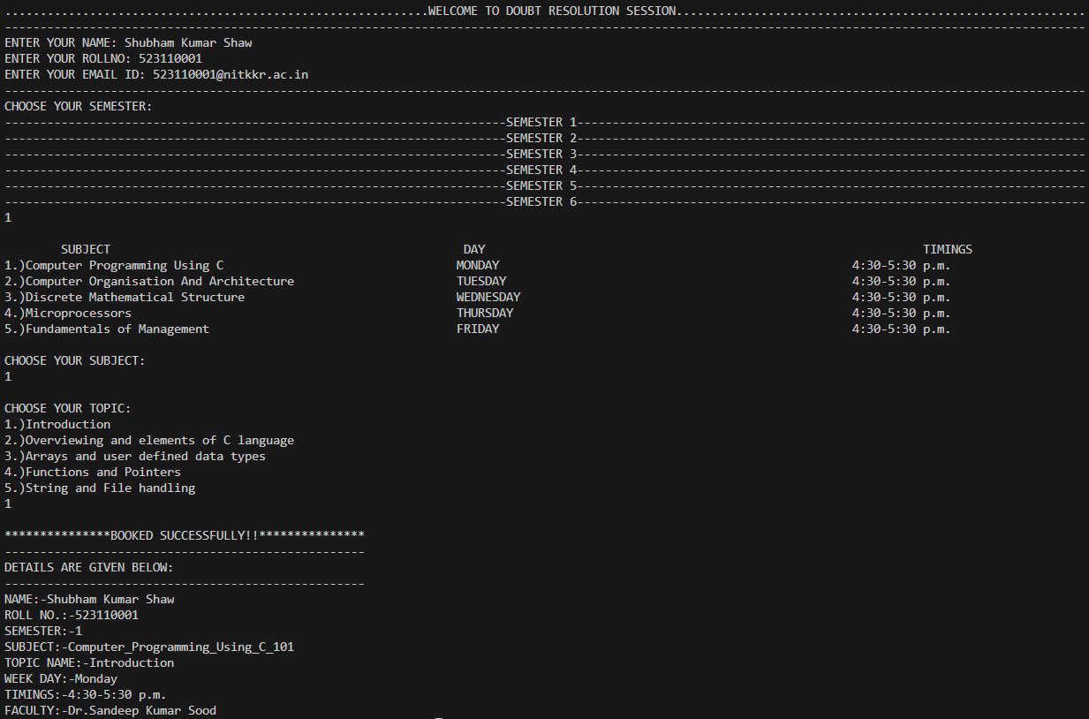

Sem2 :-

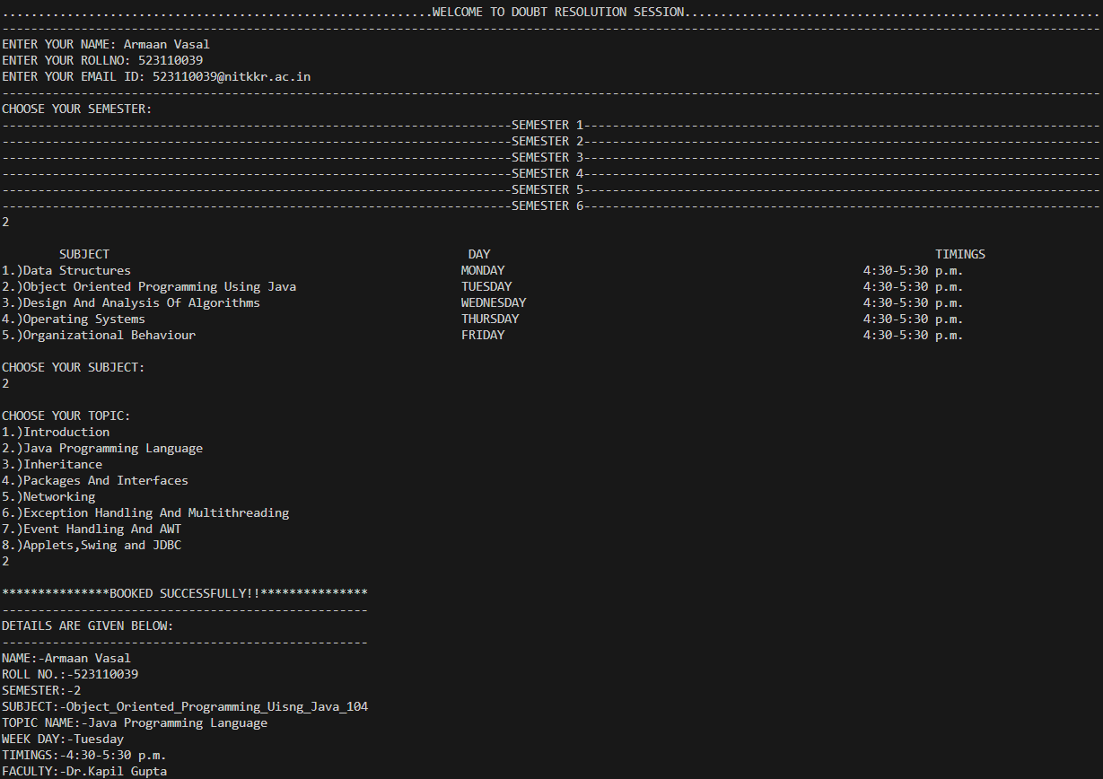

Sem3 :-

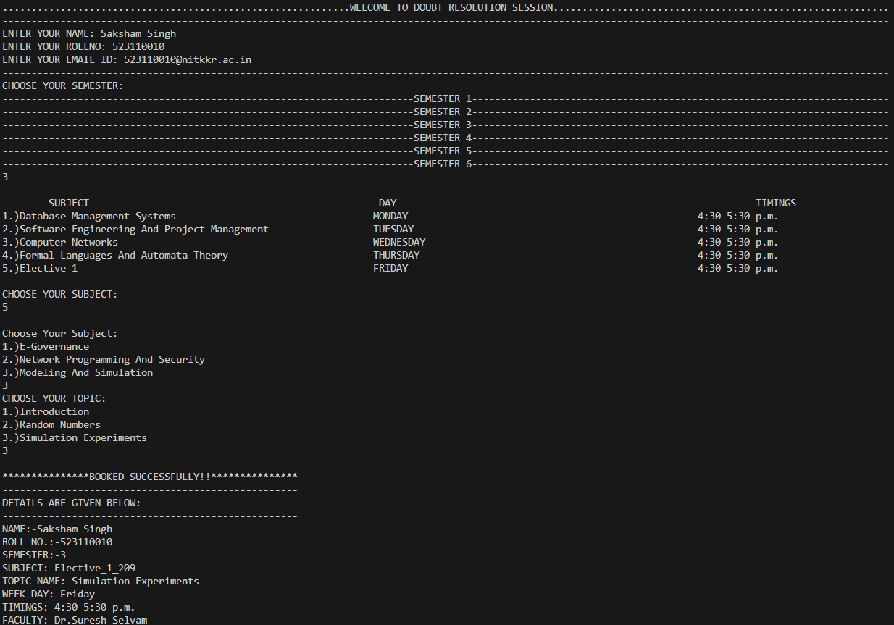

Sem4 :-

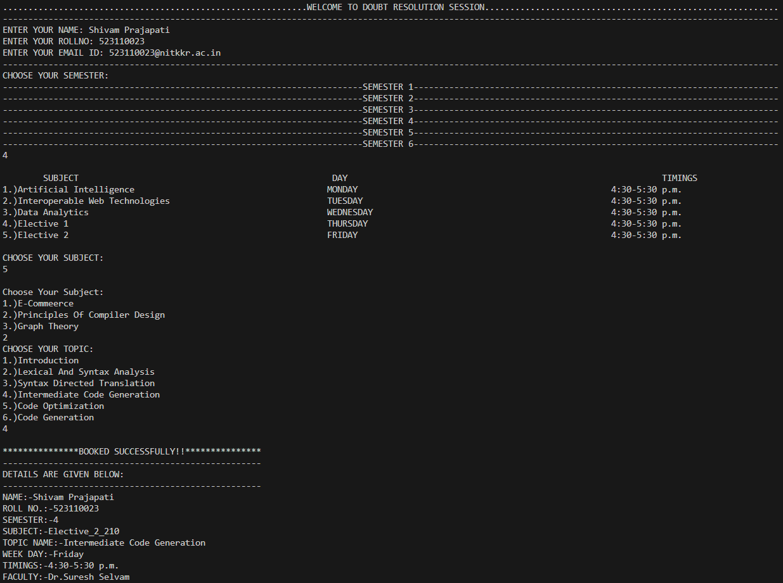

Sem5 :-

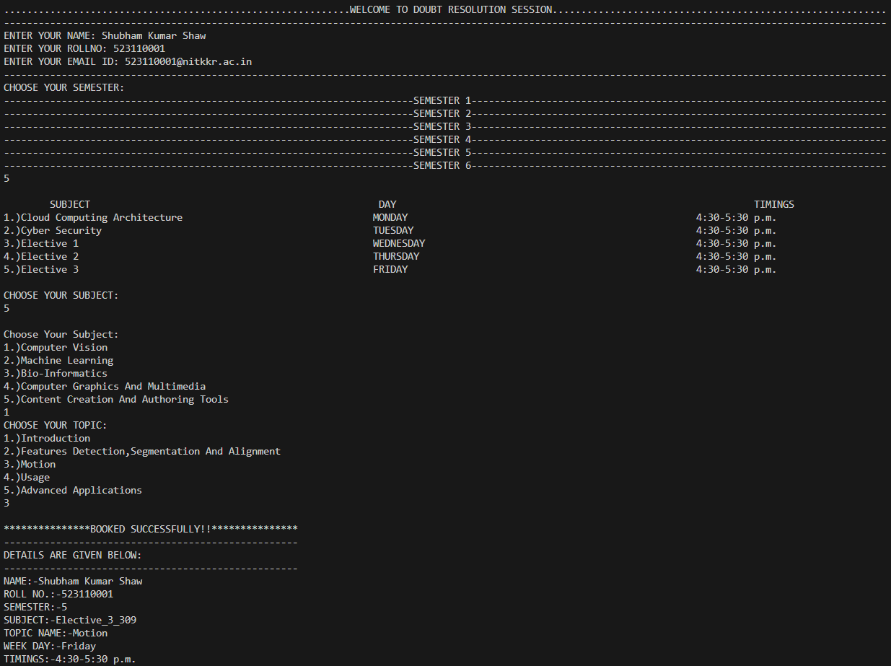

Sem6 :-

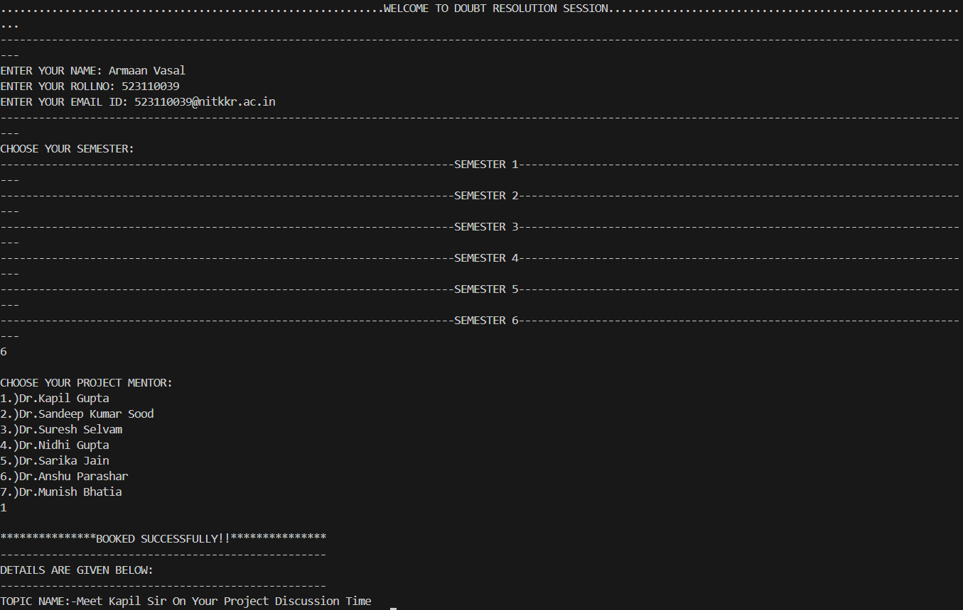

**CONCLUSION**

The doubt resolution project aimed to address and resolve uncertainties or questions within a specific context. After thorough analysis and investigation, the project has successfully achieved its objectives. The key findings and resolutions have been documented, providing clarity on previously ambiguous or unclear aspects. The project has not only enhanced understanding but also contributed to improved decision-making and problem-solving within the given domain. Overall, the doubt resolution project can be deemed a success, as it has effectively tackled uncertainties and promoted a more informed and confident approach within the targeted area.

Embark on this journey with us as we strive to unravel the mysteries of the unknown and build a community where doubts are not obstacles but stepping stones towards greater understanding.

**REFERENCE**

* W3SHOOL <https://www.w3schools.com/>
* JavatPoint <https://www.javatpoint.com/>
* Draw.io <https://www.drawio.com/>
* ChatGPT <https://chat.openai.com/>
* GeeksforGeeks <https://www.geeksforgeeks.org/java/>

**BIBLOGRAPHY**

The following reference has been used to develop the project :-

### 1. Effective Java by Joshua Bloch

### 2. **Thinking in Java (4th Edition)**

3. Web source :-

* + [www.google.co.in](http://www.google.co.in/)
  + [www.tutorialspoint.com](http://www.tutorialspoint.com/)
  + www.youtube.com
  + <www.stackoverflow.com>